Day
# Source: AI Source: Provided by: [Data Path: Persons Table -> ID Column: 1, Name_En Column: Motasem Essam] -> From: [ChatGPT] on [7/17/2026]
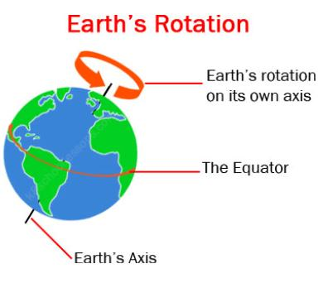
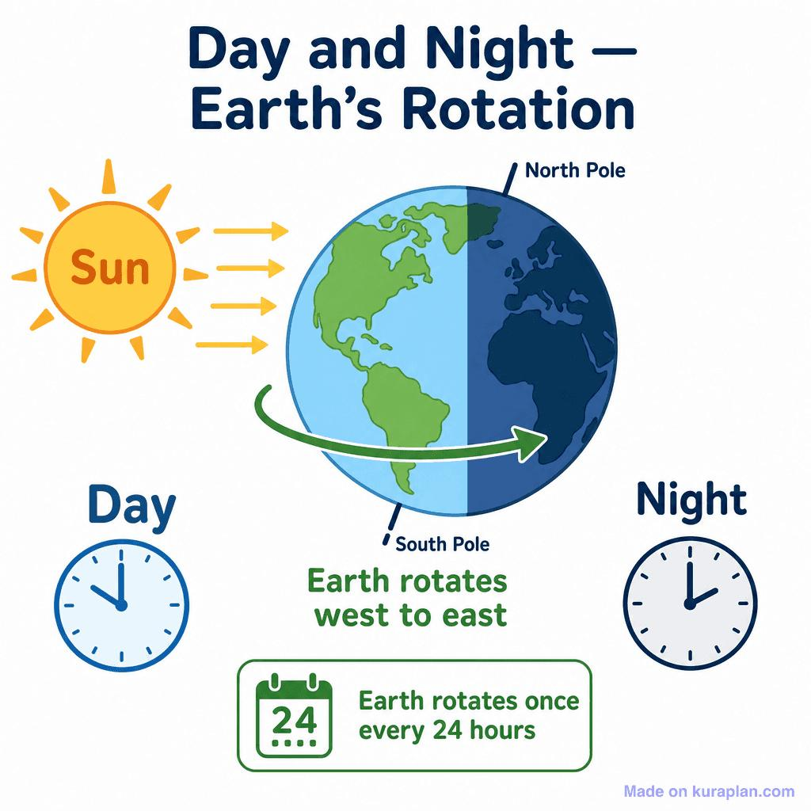
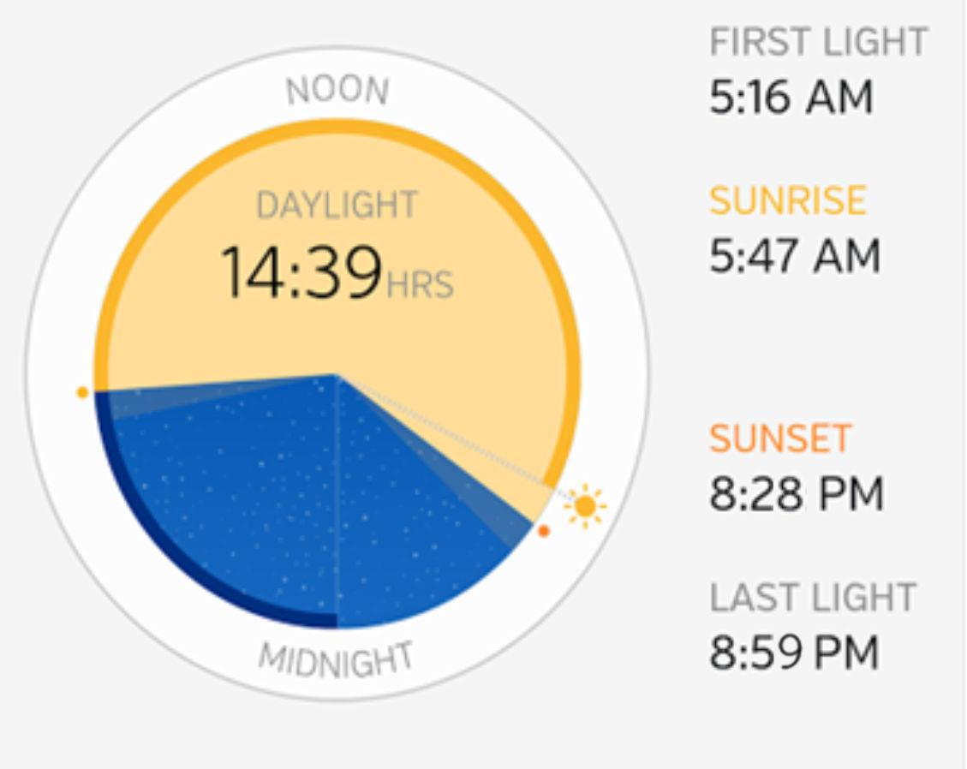
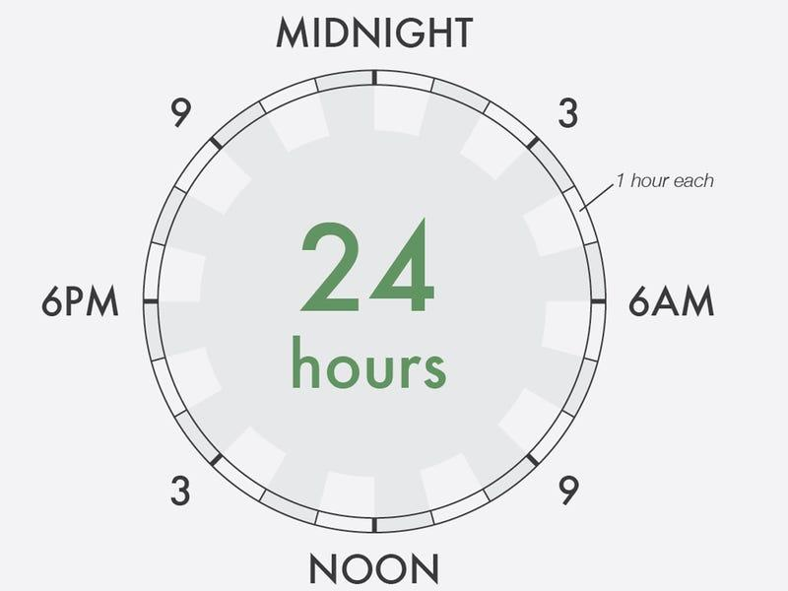
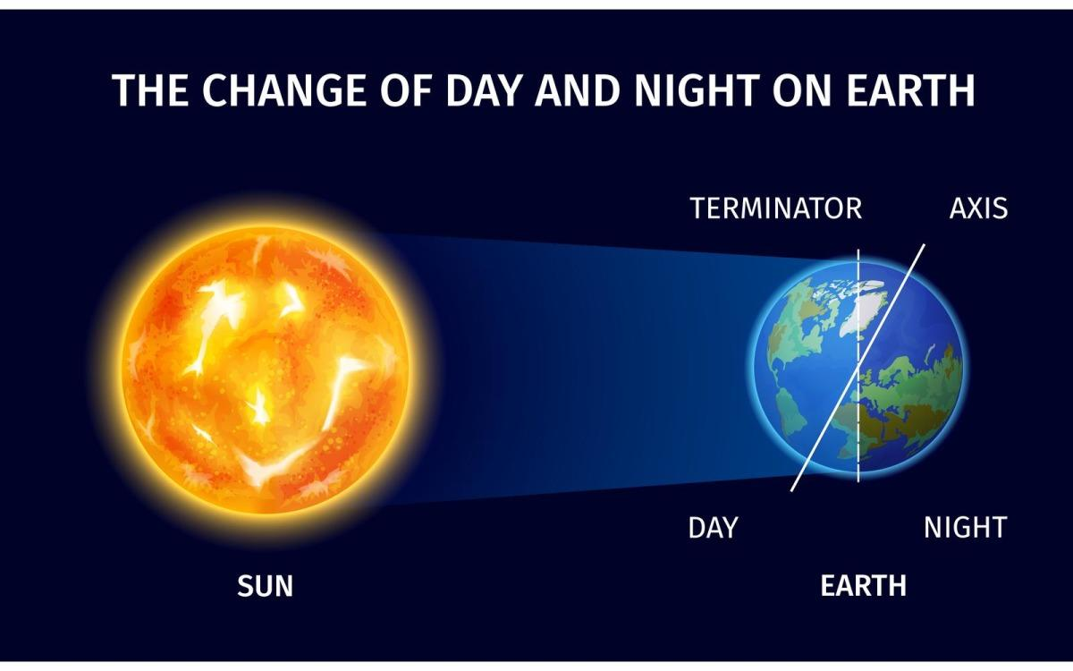
A Day is the basic unit of time commonly used to measure the interval during which the Earth completes one full rotation on its axis. This rotation produces the continuous cycle of daylight and darkness (night).
A standard civil day consists of 24 hours and serves as the foundation for calendars, clocks, schedules, and nearly all systems of timekeeping.

Definition
# Source: AI Source: Provided by: [Data Path: Persons Table -> ID Column: 1, Name_En Column: Motasem Essam] -> From: [ChatGPT] on [7/17/2026]
A Day is the standard unit of time equal to one complete rotation of the Earth on its axis, commonly divided into 24 hours.

Astronomical Basis
# Source: AI Source: Provided by: [Data Path: Persons Table -> ID Column: 1, Name_En Column: Motasem Essam] -> From: [ChatGPT] on [7/17/2026]
A day exists because:
- The Earth rotates on its axis.
- One side of the Earth faces the Sun (daytime).
- The opposite side faces away from the Sun (nighttime).
One complete rotation produces one full day–night cycle.

Standard Length
# Source: AI Source: Provided by: [Data Path: Persons Table -> ID Column: 1, Name_En Column: Motasem Essam] -> From: [ChatGPT] on [7/17/2026]
A standard civil day contains:
- 24 hours
Equivalent to:
- 1,440 minutes
- 86,400 seconds

Structure of a Day
# Source: AI Source: Provided by: [Data Path: Persons Table -> ID Column: 1, Name_En Column: Motasem Essam] -> From: [ChatGPT] on [7/17/2026]

Unit | Equivalent
1 Day | 24 Hours
1 Day | 1,440 Minutes
1 Day | 86,400 Seconds

Parts of the Day
# Source: AI Source: Provided by: [Data Path: Persons Table -> ID Column: 1, Name_En Column: Motasem Essam] -> From: [ChatGPT] on [7/17/2026]
A day is commonly divided into:

Part | Description
Dawn | Beginning of daylight before sunrise
Morning | Sunrise to noon
Afternoon | Noon to evening
Evening | Late part of the day before night
Night | Sunset to sunrise

Day and Night
# Source: AI Source: Provided by: [Data Path: Persons Table -> ID Column: 1, Name_En Column: Motasem Essam] -> From: [ChatGPT] on [7/17/2026]
The Earth's rotation creates:
- Day – the side facing the Sun.
- Night – the side facing away from the Sun.
This cycle repeats approximately every 24 hours.

Civil Day
# Source: AI Source: Provided by: [Data Path: Persons Table -> ID Column: 1, Name_En Column: Motasem Essam] -> From: [ChatGPT] on [7/17/2026]
The civil day used worldwide:
- Begins at 12:00 AM (midnight).
- Ends at the next 12:00 AM.

Astronomical Day
# Source: AI Source: Provided by: [Data Path: Persons Table -> ID Column: 1, Name_En Column: Motasem Essam] -> From: [ChatGPT] on [7/17/2026]
Astronomers distinguish between different definitions:
Solar Day
- Time between two successive noons.
- Approximately 24 hours.
Sidereal Day
- Time required for the Earth to rotate once relative to distant stars.
Length:
- Approximately 23 hours 56 minutes 4 seconds.

Time Formats
# Source: AI Source: Provided by: [Data Path: Persons Table -> ID Column: 1, Name_En Column: Motasem Essam] -> From: [ChatGPT] on [7/17/2026]
12-Hour Format
Examples:
- 8:00 AM
- 2:30 PM
- 11:45 PM
Uses:
- AM (before noon)
- PM (after noon)

24-Hour Format
# Source: AI Source: Provided by: [Data Path: Persons Table -> ID Column: 1, Name_En Column: Motasem Essam] -> From: [ChatGPT] on [7/17/2026]
Examples:
- 08:00
- 14:30
- 23:45
Widely used in:
- Military
- Aviation
- Science
- International transportation

Applications
# Source: AI Source: Provided by: [Data Path: Persons Table -> ID Column: 1, Name_En Column: Motasem Essam] -> From: [ChatGPT] on [7/17/2026]
A day is used in:
- Calendars
- Clocks
- School schedules
- Business hours
- Transportation timetables
- Scientific observations
- Computing systems

Advantages
# Source: AI Source: Provided by: [Data Path: Persons Table -> ID Column: 1, Name_En Column: Motasem Essam] -> From: [ChatGPT] on [7/17/2026]
Using the day as a unit of time:
- Standardizes daily activities.
- Organizes work and education.
- Supports global communication.
- Provides a consistent basis for calendars and clocks.

Common Mistakes
# Source: AI Source: Provided by: [Data Path: Persons Table -> ID Column: 1, Name_En Column: Motasem Essam] -> From: [ChatGPT] on [7/17/2026]
- Assuming every astronomical day is exactly 24 hours (a sidereal day is slightly shorter).
- Confusing AM and PM in the 12-hour clock.
- Believing sunrise and sunset always occur at the same time each day (they vary with season and location).

Related Units
# Source: AI Source: Provided by: [Data Path: Persons Table -> ID Column: 1, Name_En Column: Motasem Essam] -> From: [ChatGPT] on [7/17/2026]
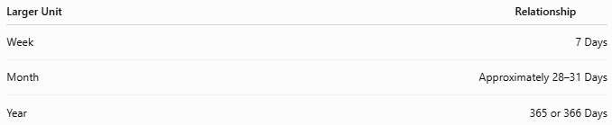
Larger Unit | Relationship
Week | 7 Days
Month | Approximately 28–31 Days
Year | 365 or 366 Days

Key Points
# Source: AI Source: Provided by: [Data Path: Persons Table -> ID Column: 1, Name_En Column: Motasem Essam] -> From: [ChatGPT] on [7/17/2026]
- A Day is one complete rotation of the Earth on its axis.
- A standard day contains:
  - 24 hours
  - 1,440 minutes
  - 86,400 seconds
- Earth's rotation produces the cycle of day and night.
- Days are used as the fundamental unit for calendars, clocks, and everyday timekeeping.

Conclusion
# Source: AI Source: Provided by: [Data Path: Persons Table -> ID Column: 1, Name_En Column: Motasem Essam] -> From: [ChatGPT] on [7/17/2026]
A Day is the fundamental unit of time based on the Earth's rotation on its axis. Lasting 24 hours in civil time, it provides the repeating cycle of daylight and darkness that structures human life. Divided into hours, minutes, and seconds, the day forms the basis for calendars, schedules, scientific measurements, and nearly every system of modern timekeeping.

